The ninth annual Guns and Hoses Softball game highlighted the “friendly rivalry” between local law enforcements and fire crews. And it also showed the camaraderie between the first responders. The two agencies sold about 290 tickets for the game, Michael McGrew, K-9 officer for Frederick Police Department said. They raised $2,785 for the Frederick Optimist Club.
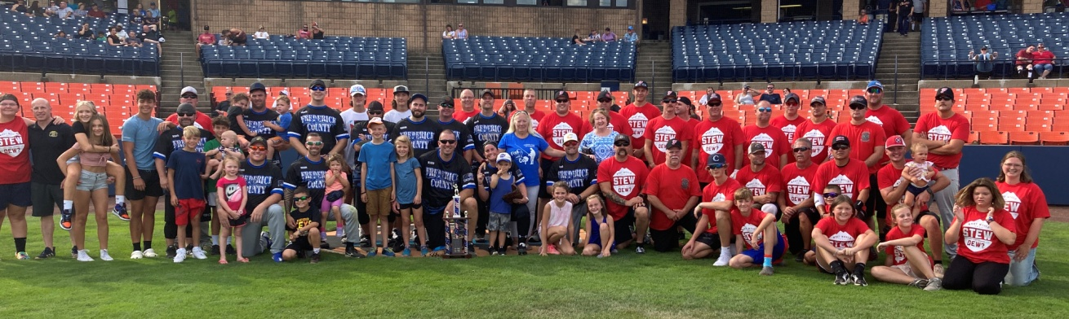

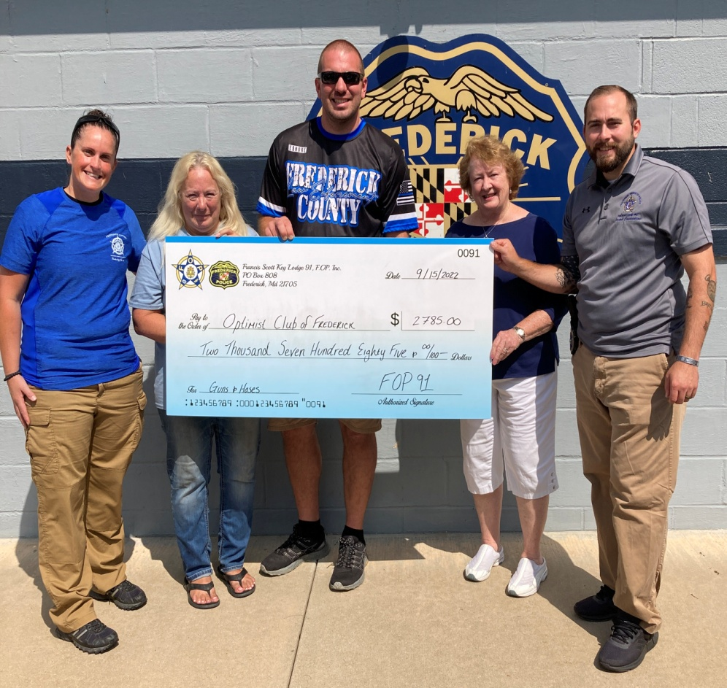
Presentation of the check from the proceeds of the Guns and Hoses Softball game.
Left to right: Deputy Amber Owens, Julie Zebroski Optimist President, Michael McGrew
Frederick Police Department, Mary Ellen Hoffman club member, Joseph Constantine FPD

